**Mining Assessments’ Data and Results Reveals that Supervised   
e-Learning is a “MUST”: Case Study**

## Abstract: Online assessments are important e-Learning activity that is being utilized in different e-Learning types. Online assessments are not always conducted in secure and supervised e-Learning environments due to different reasons. In the attempt to rely heavily on e-Learning, some challenges arise. One of them is to rely on unsupervised e-Learning. Another one is the limited capabilities of current Learning Management Systems (LMSs). LMSs don’t present advanced statistical analysis tools to further study students’ behavior in online assessments. In this paper, the results of analyzing non-supervised online assessments in the academic years 2007-08, 2008-09 is presented, leading to research study questions about identifying cheating conditions in those assessments. In order to study, identify, and compare students’ behavior in both supervised and non-supervised environments, comparative study of six assessments were conducted in the academic year 2009-10. Results were completely towards the importance of utilizing supervised e-Learning environments. Further data mining techniques were applied to assessments’ results in the attempt to identify gender tendencies for online assessments. Mining yields that females always tend to be within categories that score very high or high grades, on the contrary of males that don’t mind being part of categories that scores very low or low grades.

**Keywords:** Supervised e-Learning, Online Assessments, Mining e-Learning Data, Moodle, Statistical Analysis of e-Learning Data

1. **Introduction**

One of the courses taught in Faculty of Computers and Information Sciences in Mansoura University of Egypt is “Information Systems Analysis and Design,” a course which utilizes different features of learning and e-learning activities. One of the activities that have been utilized since 2008 is online assessment. Though online assessment is not the only criteria to qualify students, it is still an important feature because of the many advantages of enhancing learning experience, automated assessments marking, assessments and assessments’ items analysis, and students’ profiles features. However, one of the problems that prevent us from taking full advantage of online assessments is when students leak the assessments to others—in other words, cheat. Students search online for the questions and answers, and unfortunately, they can generally find them easily enough. Screenshots of questions, answers, final grade of those answers, and attendance date of the exams often come up in search results. Of course, it is students’ choice to seek and use this information, or not. Online assessments are not conducted in a secure and supervised environment. The argument is that distance learning is based on the ability to provide different types of activities for remote students that they can complete in their own time and environment. Tracking, analyzing, and mining online assessments data and results of this course for the last three years reveals important facts about unsupervised learning environments, specifically unsupervised online assessments. During assessment results’ analysis, some surprising facts became clear.

* 1. **Current LMSs Statistical and Analysis Built-in Tools**

Different e-Learning systems can be utilized based on the different learning scenarios presented and utilized within educational institutions. El-Ghareeb (2009) presents a comparison between different learning paradigms, and lists most of the LMSs available. Moodle is an open source LMS that is widely used in learning institutions and provides most of the main functionalities required by e-Learning (Romero et al., 2007). With the desire to rely heavily on e-Learning in ranking students, the idea of studying students’ online behavior and further analyze it has turned into a priority. There are differences between traditional and online assessments, and those differences can’t be neglected (Rovai, 2000). One of those differences is related to the non-supervised nature of online assessments when compared to supervised online assessments conducted inside faculty labs for example. The initiatives to utilize unsupervised e-Learning in online assessments started in the academic years 2007-08. Unfortunately Moodle doesn’t provide extensive assessment analysis tools for assessments’ data. Figure 1 presents one of the available tools that is called Item Analysis. This tool focuses on identifying the percentage of students answered each question correctly, and thus might give an indicator on students’ performance. Figure 2 presents a sample on automatic bar graphs generated by Moodle based on students’ grades. X-axis identifies grade and Y-axis identifies number of students. Compared to the necessity to further study students’ behavior, those two tools don’t seem enough in identifying different parameters. Luckily, Moodle supports exporting assessments’ data in ODS, Excel, and Text formats. Figure 3 presents a sample data that can be exported.

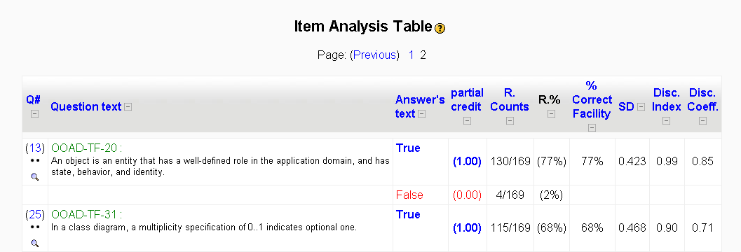

Figure : Item Analysis Table Tool - Provided by Moodle

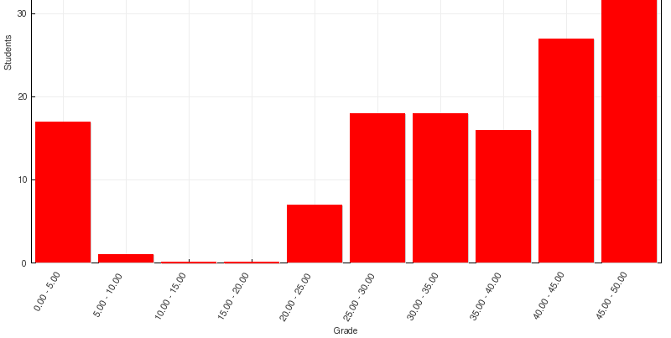

Figure : Bar Graph of Number of Students Achieving Grade Ranges Tool - Provided by Moodle

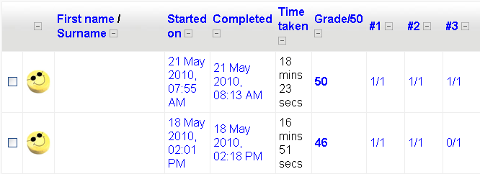

Figure : Assessments' Results Data - Provided by Moodle

* 1. **Mining e-Learning Data**

Data mining tools, techniques, and models have been widely utilized over e-Learning data in different perspectives. Romero and Ventura (2007) surveyed educational data mining from 1995 to 2005. They also present different scenarios for mining e-Learning data in their edited book (Romero and Ventura, 2006). Scenarios include mining log files, web mining of usage data, defining interactions between learning contents, and targeting data mining for personalization. Another utilization of mining; that is text mining in identifying e-Learning documents and grouping them is introduced by Hammouda and Kamel (2006). In this paper, we utilize data mining models on assessments’ data and results in order to categorize students into different meaning categories to take a closer look on students’ behavior and further analyze it. Different mining algorithms and tools can be utilized in e-Learning domain. This paper utilizes Microsoft Analysis Services that is shipped with Microsoft SQL Server 2008 R2, and connects to it via Microsoft Excel Data Mining Add-in. This model provides technical flexibility and efficiency that is not available in many other models. Microsoft presents different mining algorithms and models classified based on the user requirements (SQL Server 2008 Books Online, 2009a). One of the heavily utilized algorithms in this paper is the Microsoft Clustering Algorithm. Microsoft Clustering algorithm is a segmentation algorithm that uses iterative techniques to group cases in a dataset into clusters that contain similar characteristics. These groupings are useful for exploring data, identifying anomalies in the data, and creating predictions (SQL Server 2008 Books Online, 2009b). The clustering algorithm differs from other data mining algorithms in that it do not have to be designated with a predictable column to be able to build a clustering model. The clustering algorithm trains the model strictly from the relationships that exist in the data and from the clusters that the algorithm identifies (SQL Server 2008 Books Online, 2009b).

This paper goes as follows: Section two presents statistical analysis of unsupervised online assessments conducted in earlier academic years and identifies the research questions and problem domain analysis, section three presents the comparison study between supervised and non-supervised online assessments conducted in the academic year 2009-10, further analysis of those statistics, and comments on results. Section four presents some utilized mining tools and techniques in the attempt to gain information from conducted assessments to perform behavioral analysis on data, and presents gender as a new input parameter. Section five discusses some cheating tips witnessed through monitoring students. Section six presents a proposed pedagogical and technical solution and Section seven concludes the paper. Paper ends with references.

1. **Unsupervised Online Assessments’ Problem Domain Analysis**

The three assessments’ data was exported in Excel format and further analyzed to define students’ behavior. Further analysis has yielded some worth attention remarks. Table 1 presents statistics about the three unsupervised online assessments conducted in the academic years 2007-08, and 2008-09. Utilized questions in those assessments are very well prepared; some of them are available via the resources available from the book author(s), and the rest are prepared internally. Number of students with high grades in an almost “not enough time to read the questions” is high. There were a noticeable number of students who finished the assessment in less than 10 minutes and scored higher than 30 out of 50. Luckily, the students do not know that the system records their starting time and ending time, and thus total time, or they would have at least spent more time on screen just pretending to be read and think through each question. In order to take a closer look on quizzes’ data, students were categorized into six groups based on the time consumed within each quiz. Table 2 presents the different groups in this paper. Participation in those assessments was on voluntary basis and this justifies the low participation level in some cases. However, this doesn’t give an excuse for careless students who didn’t participate.

Table : Statistics for 3 Earlier Unsupervised Online Assessments

|  |  |  |  |
| --- | --- | --- | --- |
|  | 1st 2008 | 2nd 2008 | 1st 2009 |
| Enrolled Students | 223 | 223 | 184 |
| Online Students | 183 | 162 | 91 |
| Total Marks | 50 | 50 | 50 |
| Time Average | 19.8 min. | 18.7 min. | 19.8 min. |
| Marks Average | 34 | 39 | 30.5 |
| Total No. of Questions | 50 | 50 | 50 |
| Types of Questions | T/F | T/F | T/F |
| Overall Difficulty Level | Medium | Medium | Medium |
| T/F Questions | 50 | 50 | 50 |
| Easy T/F Questions | 5 | 4 | 5 |
| Medium T/F Questions | 35 | 44 | 35 |
| Hard T/F Questions | 10 | 2 | 10 |
| Group 0 | 4 | 9 | 0 |
| Group 1 | 52 | 46 | 32 |
| Group 2 | 63 | 52 | 22 |
| Group 3 | 28 | 29 | 20 |
| Group 4 | 11 | 11 | 4 |
| Group 5 | 14 | 5 | 7 |
| Group 6 | 11 | 10 | 6 |

Table : Different Students Groups

|  |  |
| --- | --- |
| **Group 0** | Students started but did not complete the assessment. |
| **Group 1** | Students conducted the assessment in duration between 0 and 10 min. |
| **Group 2** | Students conducted the assessment in duration between 10 and 20 min. |
| **Group 3** | Students conducted the assessment in duration between 20 and 30 min. |
| **Group 4** | Students conducted the assessment in duration between 30 and 40 min. |
| **Group 5** | Students conducted the assessment in duration between 40 and 50 min. |
| **Group 6** | Students conducted the assessment in duration between 50 and 60 min. |

Gipps (1994) defines different aspects of assessments. Successful assessments refer to assessments that can effectively and efficiently differentiate different learning skills gained and acquired by different students. Successful assessments’ components are: consumed time, scored marks, and questions answered. In the attempt to identify the relations between those components; especially between consumed time and scored marks, some graphs that summarize analysis of the assessments are presented. Figure 4 shows the percentage of students with variant assessment completion times for the three assessments respectively. Figure 5 shows the time distribution of students per each quiz. Figure 6 shows marks distribution for students per each quiz. Figure 7 highlights the relevance between times consumed solving the assessments and scored marks. There are some alarming remarks that took place in the three unsupervised assessments:

* Around 25% of students belong to Group 1. Group 1 students’ finish assessment within less than 10 minutes; which is believed not to be enough time just for reading the assessment, not for thinking about it and solving it.
* There are no clear relations between consumed times solving the assessments and scored marks.
* In 1st Quiz 2008 results, students spent longer time solving the quiz and scored lower marks than students conducted the 2nd Quiz 2008 though both quizzes consist of the same number of questions and same type of questions.
* In 1st Quiz 2009, students spent less time solving the quiz and scored much less marks than other students.
* In the three quizzes, Groups 4, 5, and 6 percentages are low, and their marks are not the highest. What would be those students’ response if the amount of time allowed for the assessment shortens? Would they join Group 3 with the same scored marks?

Besides, there are some questions that need answer via experiencing different alternatives. Questions include:

* What is the most type of questions that students take longer time answering from the True/False, Matching, and Multiple Choice Questions?
* Is it better to mix the three types of questions together within the assessment?
* What is the relation between genders, consumed time, and scored marks?
* What are other data that can be extracted from further analyzing and mining assessments’ results and data?
* Can non-supervised environment assessments be reliable enough in grading students?

|  |  |
| --- | --- |
| GroupPcntgOldQuizzes.png  Figure 4: Group Percentages Per Assessment | TimeDistributionOldQuizzes.png  Figure 5: Time Distribution Per Assessment |
| MarksDistributionOldQuizzes.png  Figure 6: Marks Distribution Per Assessment | TimeMarksRelevanceOldQuizzes.png  Figure 7: Time and Marks Relevance Per Assessment |

1. **Comparison Study between Unsupervised and Supervised Online Assessments**

Six different assessments were conducted in both supervised and non-supervised environments to highlight differences between both environments and to test to what extent there are leaks in non-supervised environment assessments. Table 3 presents data about those assessments. Different types of questions were presented hopefully to identify the most efficient types of questions to be used. Figure 8 presents an enhanced assessments’ authoring model via utilizing available spreadsheets applications and data mining tools and techniques. This model is applied in this paper to enhance the assessments lifecycle. Table 4 presents further statistics for each quiz based on Groups’ percentages and compares between each group in both the supervised and non-supervised environments. Figure 9 presents a representation of the data presented in table 4.

Table : Statistics about the Six conducted assessments in 2009-10

|  |  |  |  |  |  |  |
| --- | --- | --- | --- | --- | --- | --- |
|  | 1st Quiz | 2nd Quiz | 3rd Quiz | 4th Quiz | 5th Quiz | 6th Quiz |
| Quiz Title | Quiz 1 | Quiz 2 | Quiz 3 | Quiz 4 | Quiz 5 | Quiz 6 |
| Total Marks | 50 | 50 | 25 | 50 | 50 | 50 |
| Total No. of Questions | 50 | 50 | 20 | 50 | 50 | 50 |
| Types of Questions | T/F | MCQ | Match | Mix | Mix | Mix |
| Overall Difficulty Level | Med. | Med. | Med. | Med. | Med. | Med. |
| T/F Questions | 50 | 0 | 0 | 20 | 20 | 20 |
| Easy T/F Questions | 5 | 0 | 0 | 2 | 2 | 3 |
| Medium T/F Questions | 35 | 0 | 0 | 14 | 17 | 17 |
| Hard T/F Questions | 10 | 0 | 0 | 4 | 1 | 0 |
| Multi Choice Questions | 0 | 50 | 0 | 10 | 10 | 10 |
| Easy MCQs | 0 | 3 | 0 | 0 | 0 | 1 |
| Medium MCQs | 0 | 39 | 0 | 8 | 9 | 8 |
| Hard MCQs | 0 | 8 | 0 | 2 | 1 | 1 |
| Match Questions | 0 | 0 | 20 | 20 | 20 | 20 |

Figure 8: Enhanced Quizzes' Authoring Lifecycle

Table 4: Detailed Quizzes' Statistics

|  |  |  |  |  |  |  |  |  |  |  |  |  |
| --- | --- | --- | --- | --- | --- | --- | --- | --- | --- | --- | --- | --- |
|  | 1st Quiz | | 2nd Quiz | | 3rd Quiz | | 4th Quiz | | 5th Quiz | | 6th Quiz | |
|  | Online | Lab | Online | Lab | Online | Lab | Online | Lab | Online | Lab | Online | Lab |
| Total Students | 212 | 212 | 212 | 212 | 212 | 212 | 212 | 212 | 212 | 212 | 212 | 212 |
| Enrolled Students | 167 | 46 | 170 | 45 | 166 | 50 | 160 | 69 | 155 | 66 | 153 | 65 |
| Time Average | 24.8 | 16.8 | 26.4 | 21.4 | 7.8 | 3.6 | 22 | 15 | 17 | 15 | 15.4 | 12.7 |
| Marks Average | 39.5 | 29.9 | 39 | 26 | 22 | 15.7 | 35 | 26 | 43.6 | 30 | 42.8 | 21.8 |
| Group 0 | 29 | 0 | 21 | 0 | 5 | 2 | 14 | 0 | 14 | 0 | 13 | 0 |
| Group 1 | 23 | 10 | 22 | 2 | 130 | 38 | 36 | 21 | 37 | 20 | 44 | 29 |
| Group 2 | 40 | 27 | 33 | 20 | 23 | 10 | 41 | 27 | 63 | 32 | 66 | 24 |
| Group 3 | 34 | 5 | 37 | 18 | 7 | 0 | 37 | 17 | 25 | 10 | 17 | 10 |
| Group 4 | 13 | 1 | 26 | 4 | 1 | 0 | 13 | 4 | 7 | 3 | 8 | 1 |
| Group 5 | 14 | 2 | 20 | 1 | 0 | 0 | 7 | 0 | 5 | 1 | 3 | 1 |
| Group 6 | 14 | 1 | 11 | 0 | 0 | 0 | 12 | 0 | 4 | 0 | 2 | 0 |

Table : Further Statistical Analysis based on Grous' Responses

|  |  |  |  |  |  |  |  |
| --- | --- | --- | --- | --- | --- | --- | --- |
|  | Quiz 1 | | | | | | PcntgCorrectAnswersGroupsQuiz1.png  Figure 9: Percentage of Correct Answers for Each Group Based on Questions Difficulty |
| T/F Qs | | | | | |
| Easy  Online | Easy Lab | Med. Online | Med. Lab | Hard Online | Hard Lab |
| Group 0 | 0 | 0 | 0 | 0 | 0 | 0 |
| Group 1 | 84/115 | 17/30 | 543/805 | 564/858 | 141/230 | 118/176 |
| Group 2 | 135/200 | 38/81 | 1159/1400 | 618/1053 | 68/400 | 172/216 |
| Group 3 | 119/170 | 8/15 | 1033/1190 | 105/195 | 59/340 | 29/40 |
| Group 4 | 47/65 | 1/3 | 380/455 | 26/39 | 21/130 | 6/8 |
| Group 5 | 51/70 | 4/6 | 407/490 | 56/78 | 24/140 | 15/16 |
| Group 6 | 39/70 | 2/3 | 322/490 | 23/39 | 14/140 | 6/8 |
|  |  |  |  |  |  |  |

In this comparison study, students were divided into three groups based on their Student IDs: Group A, Group B, and Group C. Group A include students that are asked to attend the assessment in lab (supervised environment). Group B are students asked to attend the assessments in non-supervised environment. Group C are students asked to attend the assessments in both supervised and non-supervised environments. Group C are voluntary basis, and they represent intersection between Group A and Group B, and their presence justifies the sum of lab and online students quizzes exceeds the total enrolled students. Presented statistics are an example of data that is made available via utilizing spreadsheets applications. This data can be used in identifying what types of questions each group failed in answering and then modifying upcoming assessments. Figure 9 presents a graph that turns statistics presented in table 5 into meaningful information. This figure summarizes the percentages of correct answers from each group in Quiz 1 categorized in the three questions’ difficulty levels: hard, medium, and easy. Such figures highlight some useful information about students’ performance within quizzes, and can’t be acquired easily via current LMSs. It is clear from the figure that students’ percentage of answering hard questions in unsupervised environment is much less than other types of questions. This might indicate that instructors shall make non-supervised assessments include harder types of questions than supervised ones for sake of testing the real students’ achievements.

Figure 10 presents comparison between Group’s percentage per total enrolled students for supervised and non-supervised Quiz 1. Figure 11 presents time consumption comparison between supervised and non-supervised Quiz 1 instance. Figure 12 highlights marks’ comparison between supervised and non-supervised instances of quiz 1. Figures 13 to 27 present the three comparisons between supervised and non-supervised environments for the rest five quizzes respectively. By studying the comparisons between both environments and when considering the different types of questions included in the six quizzes, it becomes almost clear that:

* Matching Questions is the least type of questions that differentiates between different students’ categories when compared to True/False, and MCQs. In quiz 3, students’ distribution over different groups is different than distribution in quizzes 1, and 2. Matching questions alone weren’t efficient enough in classifying students as the other two types of questions.
* Students spend longer times in non-supervised environments solving the assessments.
* Students score higher marks in non-supervised environments than in supervised environments.
* Group 4, 5, and 6 almost disappears in supervised environments. That indicates that students take less time solving the assessments in supervised environments when compared to non-supervised environments. Though this means that there is a leak in assessments’ predetermined needed time to solve the quiz, it also indicates that students take longer time in non-supervised environments trying to reach the correct answers in a way or another via means that are not accessible in supervised environments.

|  |  |  |
| --- | --- | --- |
| GroupPcntgComparisonLabOnlineQuiz1.png  Figure 10: Quiz 1 Groups’ Percentage Comparison | TimeDistributionComparisonLabOnlineQuiz1.png  Figure 11: Quiz 1 Time Consumption Comparison | MarksDistributionComparisonLabOnlineQuiz1.png  Figure 12: Quiz 1 Scored Marks Comparison |
| GroupPcntgComparisonLabOnlineQuiz2.png  Figure 13: Quiz 2 Group's Percentage Comparison | TimeDistributionComparisonLabOnlineQuiz2.png  Figure 14: Quiz 2 Time Consumption Comparison | MarksDistributionComparisonLabOnlineQuiz2.png  Figure 15: Quiz 2 Scored Marks Comparison |
| GroupPcntgComparisonLabOnlineQuiz3.png  Figure 16: Quiz 3 Group's Percentage Comparison | TimeDistributionComparisonLabOnlineQuiz3.png  Figure 17: Quiz 3 Time Consumption Comparison | MarksDistributionComparisonLabOnlineQuiz3.png  Figure 18: Quiz 3 Scored Marks Comparison |
| GroupPcntgComparisonLabOnlineQuiz4.png  Figure 19: Quiz 4 Group's Percentage Comparison | TimeDistributionComparisonLabOnlineQuiz4.png  Figure 20: Quiz 4 Time Consumption Comparison | MarksDistributionComparisonLabOnlineQuiz4.png  Figure 21: Quiz 4 Scored Marks Comparison |
| GroupPcntgComparisonLabOnlineQuiz5.png  Figure 22: Quiz 5 Group's Percentage Comparison | TimeDistributionComparisonLabOnlineQuiz5.png  Figure 23: Quiz 5 Time Consumption Comparison | MarksDistributionComparisonLabOnlineQuiz5.png  Figure 24: Quiz 5 Scored Marks Comparison |
| GroupPcntgComparisonLabOnlineQuiz6.png  Figure 25: Quiz 6 Group's Percentage Comparison | TimeDistributionComparisonLabOnlineQuiz6.png  Figure 26: Quiz 6 Time Consumption Comparison | MarksDistributionComparisonLabOnlineQuiz6.png  Figure 27: Quiz 6 Scored Marks Comparison |

Another form of further assessments’ data and results analysis that is currently not available via LMSs tools and made easier via spreadsheets applications is the capability to distribute students of each group based on their consumed time solving the assessment, and scored marks. Table 5 presents data about the distribution of different students groups based on the relation between consumed times and scored marks. Figure 28 introduces a representational chart of this data. It is noticeable that students’ distribution over groups in supervised environments makes more sense when compared to students’ distribution in non-supervised environment. In lab assessment, groups 1, 2, and 3 mostly scored marks > 20 and <= 30 and groups 4, 6 scored marks >30 and <= 40, and that complies with the belief that statistics recorded about non-supervised environments show leaks in some areas. When compared with groups distribution of students in non-supervised environments, we find students of groups 1, 2, 3, 4, and 5 mostly scored marks > 40 and <=50, and this means in this assessment there was a leak somewhere that lead to the assessment failure to differentiate between different students. This leak of course is not in the assessment itself or the questions because when the same assessment was applied in a supervised environment, it yielded different distribution.

One of the considered determining factors to identify to what extent non-supervised environments can be relied on is the comparison between individuals’ performance in both supervised and non-supervised environments. Some students were invited personally to the conduct the assessments’ twice. Some of them attended the assessment in the supervised environment first, and then they attended it in the non-supervised environment and the others vice versa. Students’ were not told that they will conduct the same assessments twice in both cases. Comparative results are quiet impressive and gives real indication of the students’ performance in non-supervised environments. Figures 29 to 34 compare between students’ consumed time and scored marks in both supervised and non-supervised environments. It is clear from the figures that the same student spent longer time solving the assessment in non-supervised environment, and scored higher marks than s/he scored in the non-supervised environments. The difference in consumed time between both environments is not much irritating as the difference between marks.

Table : Students' Distribution Comparison within Each Group Per Scored Marks for Quiz 1

|  |  |  |  |  |  |  |  |  |  |  |  |  |  |  |  |
| --- | --- | --- | --- | --- | --- | --- | --- | --- | --- | --- | --- | --- | --- | --- | --- |
|  | <= 10 | | > 10 & <= 20 | | | > 20 & <= 30 | | > 30 & <= 40 | | | > 40 & <= 50 | | Total | | |
|  | Online | Lab | | Online | Lab | Online | Lab | | Online | Lab | Online | Lab | | **Online** | Lab |
| Group 0 | 0.0% | 0.0% | | 0.0% | 0.0% | 0.0% | 0.0% | | 0.0% | 0.0% | 0.0% | 0.0% | | **0.0%** | 0.0% |
| Group 1 | 0.0% | 0.0% | | 4.3% | 0.0% | 43.5% | 90.0% | | 21.7% | 10.0% | 30.4% | 0.0% | | **100.0%** | 100.0% |
| Group 2 | 0.0% | 0.0% | | 0.0% | 0.0% | 20.0% | 55.6% | | 12.5% | 33.3% | 67.5% | 11.1% | | **100.0%** | 100.0% |
| Group 3 | 0.0% | 0.0% | | 0.0% | 0.0% | 5.9% | 100.0% | | 26.5% | 0.0% | 67.6% | 0.0% | | **100.0%** | 100.0% |
| Group 4 | 0.0% | 0.0% | | 0.0% | 0.0% | 0.0% | 0.0% | | 46.2% | 100.0% | 53.8% | 0.0% | | **100.0%** | 100.0% |
| Group 5 | 0.0% | 0.0% | | 0.0% | 0.0% | 21.4% | 0.0% | | 21.4% | 0.0% | 57.1% | 100.0% | | **100.0%** | 100.0% |
| Group 6 | 7.1% | 0.0% | | 7.1% | 0.0% | 28.6% | 0.0% | | 50.0% | 100.0% | 7.1% | 0.0% | | **100.0%** | 100.0% |
| Total | 7.1% | 0.0% | | 11.5% | 0.0% | 119.4% | 245.6% | | 178.3% | 243.3% | 283.7% | 111.1% | |  |  |

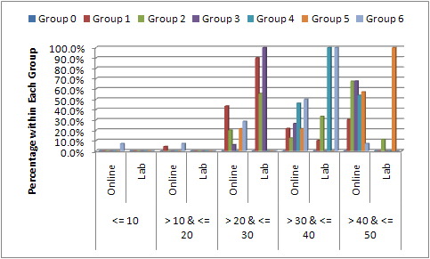

Figure 28: Students’ Distribution Comparison within each Group Per Scored Marks for Quiz

|  |  |
| --- | --- |
| Intersection-Quiz1.png  Figure 29: Quiz 1 Defined Intersection Students | Intersection-Quiz2.png  Figure 30: Quiz 2 Defined Intersection Students |
| Intersection-Quiz3.png  Figure 31: Quiz 3 Defined Intersection Students | Intersection-Quiz4.png  Figure 32: Quiz 4 Defined Intersection Students |
| Intersection-Quiz5.png  Figure 33: Quiz 5 Defined Intersection Students | Intersection-Quiz6.png  Figure 34: Quiz 6 Defined Intersection Students |

1. **Mining Assessments’ Data and Results to Identify Behavioral Characteristics**

Considering the group of students we have in this paper, this group shares demographic characteristics. Their ages range between 18 and 20, they received the same learning at least for the last three years in the faculty, and so they represent a cluster of data. By observing the columns that make up a cluster, it can be more clearly seen how records in a dataset are related to one another. The Microsoft Clustering algorithm first identifies relationships in a dataset and generates a series of clusters based on those relationships. After first defining the clusters, the algorithm calculates how well the clusters represent groupings of the points, and then tries to redefine the groupings to create clusters that better represent the data. The algorithm iterates through this process until it cannot improve the results more by redefining the clusters. The requirements for a clustering model are:

* A single key column: Each model must contain one numeric or text column that uniquely identifies each record. Compound keys are not allowed. In this paper, this single key column was identified to be Grade, as it is the main concern.
* Input columns: Each model must contain at least one input column that contains the values that are used to build the clusters. There can be as many input columns as needed, but depending on the number of values in each column, the addition of extra columns can increase the time it takes to train the model. In this paper, the time taken answering the assessment and answers of all the questions are included as input columns. In this phase, Gender is added as an input.

Figures 35 to 45 present the Microsoft Clustering Algorithm results of mining the different online and lab quizzes. First column from left shows the Gender Female : Male Ratio. Second column from left shows the grade distribution of all data. Grades vary between Very Low, Low, Medium, High, and Very High. Third column from left shows consumed time distribution and it uses the same variants used for grade. By taking a closer look on the three first columns of all data presented at figure 35 for example, it can be noticed that females are 19 and males are 27, males scored the very low, very high, and medium grades while females scored the high and low grades. Each identified category is then presented by another three columns that specifies details of this category alone. In Quiz 1 Lab results, only one category is identified based on available data. That means, the clustering algorithm couldn’t cluster data. This might be a result of few data available.

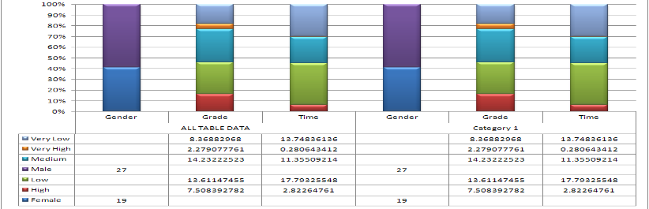

Figure 35: Mining Statistics and Results of Quiz 1 - Lab Results

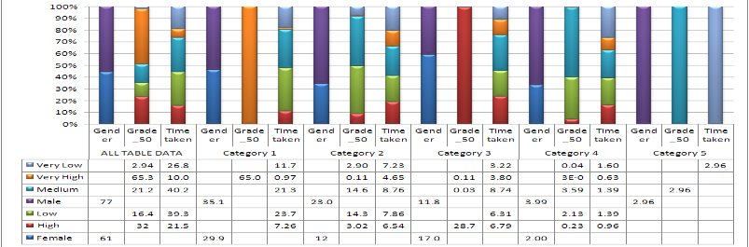

Figure 36: Mining Statistics and Results of Quiz 1 - Online Results

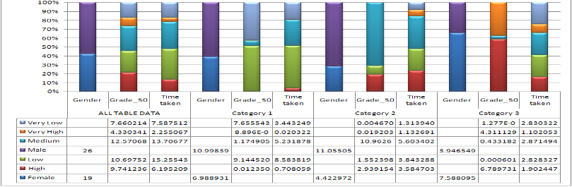

Figure 37: Mining Statistics and Results of Quiz 2 - Lab Results

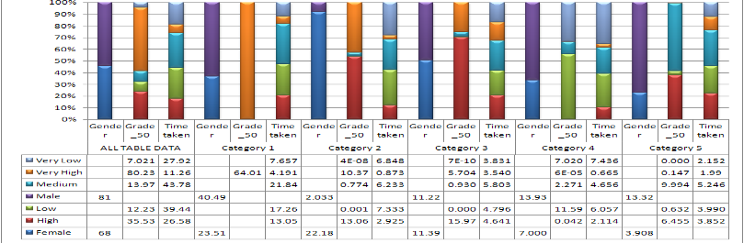

Figure 38: Mining Statistics and Results of Quiz 2 - Online Results

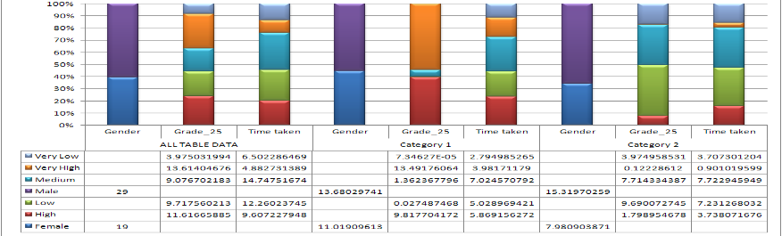

Figure 39: Mining Statistics and Results of Quiz 3 - Lab Results

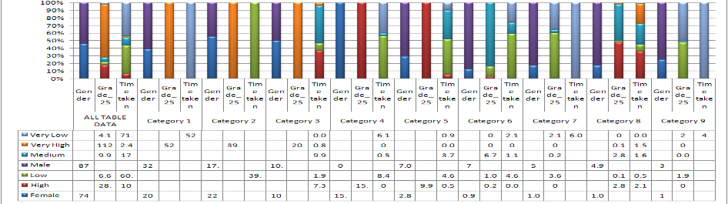

Figure 40: Mining Statistics and Results of Quiz 3 - Online Results

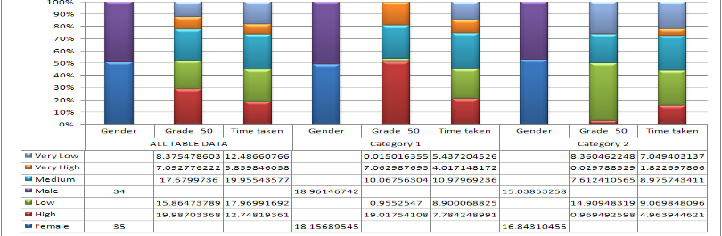

Figure 41: Mining Statistics and Results of Quiz 4 - Lab Results

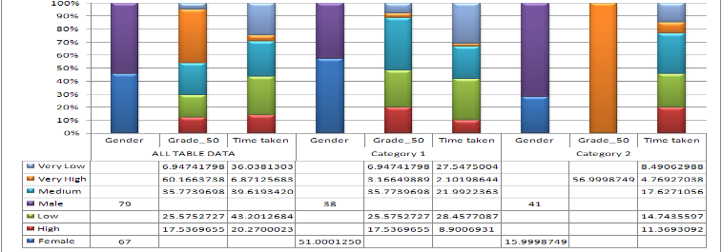

Figure 42: Mining Statistics and Results of Quiz 4 - Online Results

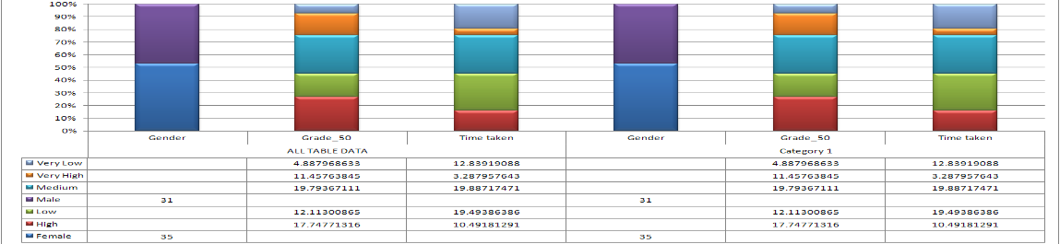

Figure 43: Mining Statistics and Results of Quiz 5 - Lab Results

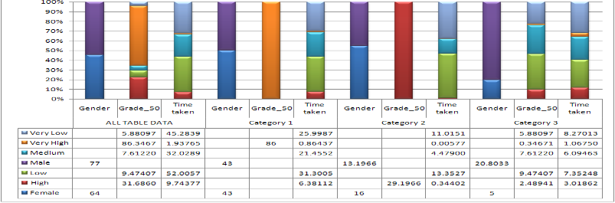

Figure 44: Mining Statistics and Results of Quiz 5 - Online Results

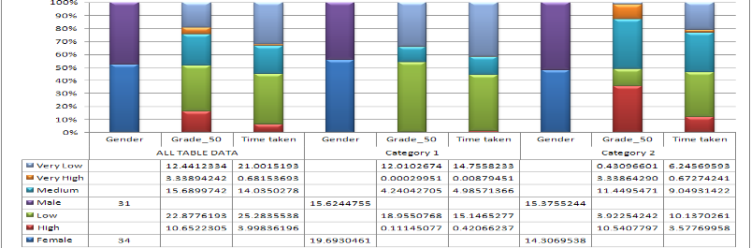

Figure 45: Mining Statistics and Results of Quiz 6 - Lab Results

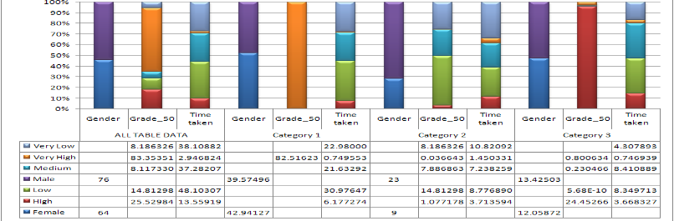

Figure 46: Mining Statistics and Results of Quiz 6 - Online Results

By further studying data mining results, some more information becomes available. Information includes:

* Students score higher rates of “Very High Grades” in non-supervised environment assessments compared to supervised assessments.
* Females score higher grades than males in both environments.
* There are almost no females in the “Very Low Grades” and “Low Grades” categories in both environments.
* Females take longer times solving the assessments in both environments when compared to males.
* Males score the most “Very High Grades” in both environments when compared to females.
* In non-supervised environment, “Very High Grades” are scored in “Very Low Time”, “Low Time”, and “Medium Time” where in supervised environment; “Very High Grades” are mostly scored in “Medium Time”, and “High Time”.

Figure 47 presents sample of category deterministic features generated by Microsoft Clustering Algorithm that is used to further study and analyze students groups’ behavior and performance.

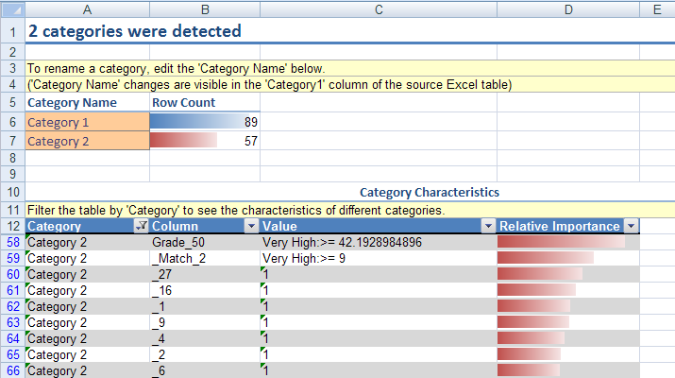

Figure 7: Category 2 Deterministic Features of Quiz 4 - Online

Figure 48 presents another useful tool that is provided via Microsoft Analysis Services and can be used to study each quiz alone. This tool is called: Analyze Key Influencers. This tool can be utilized in determining what are the most dominant questions affecting the results of this quiz. In other words: what the questions that students who scored higher grades have answered, and thus students who didn’t score higher grades have not, and on the contrary, what questions that students who scored very high grades have failed to answer, while students who scored low or very low grades have answered. In the latter case, there might be issues related to questions preparation. Microsoft Analyze Key Influencers tool takes two inputs:

* Column to analyze for key factors: in this paper, that is the Grade.
* Columns to be used for analysis: in this paper, those are the questions items. Time taken to solve the assessment is excluded because Moodle can’t identify the time taken by student to solve each question item alone.

In figure 48, questions 5, 10, and 4 for example are the three top questions distinguishing “High Grade” Group while Match Questions 1,2 are the dominant questions for the “Very Low Grade” Group. Figure 49 presents another tool that helps instructors in further studying assessments, that is Pivot Tables. Table 7 presents a sample of Pivot Tables for Assessment 4 in non-supervised environment that compares Females and Males performance, and sums the overall consumed time and scored marks. Categories identified in the Clustering phase can be used as input to present a Pivot Chart as the one in figure 49.

Table : Pivot Tables for Assessment 4 in non-supervised environment

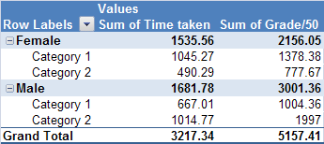

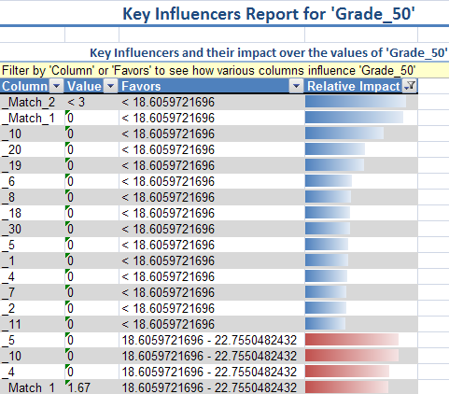

Figure 48: Key Influencers Report for Quiz 4 - Online

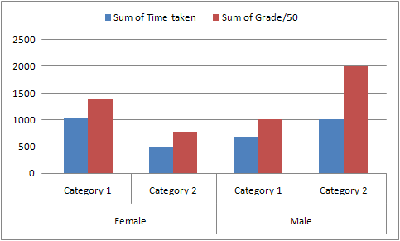

Figure : Pivot Chart of Assessment 4 in Non-Supervised Environment

1. **Monitoring Students to Get Closer Look on Cheater’s Tips**

To combat cheating, it helps to know how students are pulling it off. Here are some cheating tips that have been witnessed or discovered through monitoring students:

* Access to Answers’ Files: Open the PDF or document file of the assessment, search for keywords, and immediately apply answers. Most students have high memorable capabilities regarding mapping questions and answers.
* Collaborative Solution: Though collaboration is really important in the learning process, the concept of collaborating to cheat was wholly new to me. More than one student conducts the assessment. One holds the laptop, while others hold different pages of material or a long list of assessment answers from all previous exams. Consequently, they optimize their search time. The one holding the laptop reads the question aloud while the others conduct a search for the answers, finding it in no time. Part of the problem here is that in an unsupervised e-learning environment, there is no way to guarantee that students themselves even attended the assessment.

Two categories of students must not be neglected in reviewing this matter:

* Careless students: Some students don’t even read the assessment questions. They pick an answer and they don’t care about the results. There are students who answered 50 questions in less than 3 minutes, which gives them an average reading of 3.6 seconds for each question. Another form of careless was presented in students who did not finish the assessment even though they started it.
* Disengaged students: Almost 23 percent of the enrolled students did not attend any of the e-learning activities. This percentage is huge, and in our course, it is not acceptable at all. Motivating students to attend e-learning classes and activities is always a challenge.

1. **Proposed Solution**

Based on the findings, it is clear that there are issues that shall be considered before providing students with non-supervised online exams. There must be a stronger way of controlling the exam process; in order to make marks more trustworthy. Proposed solutions are to first conduct more studies about the efficiency and effectiveness of assessment, both educational/pedagogical and technological.

* 1. **Pedagogical Solutions**

Pedagogical solutions include attempting to present an unlimited assessment items repository, and track students’ progress during the learning process, so peaks can be determined, and they might be a mark for inappropriate activity during the learning process. Also, a timed question is almost a must in the exam process. Timer shall not only start after the student sees the question; we are thinking about calculating time for both displaying and solving the question, so theoretically, students will never find the time to cheat. This paper proposes some tips that can be used as solutions that focuses on four aspects of the online assessment process and can be thought of as the integration of the four of them:

* 1. Questions-based solution: Assessments banks should consist of a larger number of questions with the chance to have a quarter or third of the assessment different for each student. Also, instructors shall work on updating assessments’ banks and keeping it out of the students’ reach.
  2. Environment-based solution: This solution is complementary to the aforementioned one. Supervised e-learning environments are important and are the only way to guarantee a certain accepted level of learning quality. Students can find the time to search the answer files because they simply have the access to them. Hopefully when students don’t have access to such files, they might learn better.
  3. Assessment-based solution: This solution would use a timer that forces students to read questions before viewing the answers. Maybe by forcing student to wait for answers before s/he can choose one of them will be a catalyst for the student to read the question thoroughly and consider all the answers.
  4. Student-based solution: Talking to students about the importance and benefits of e-learning activities is important. Not all students yet believe in e-learning, and not all of them cared about attending the online course activities. The rest needs to be told explicitly, instead of being neglected.

Nowadays, most students do their best to play it smart, even if they will not follow the rules. Instructors need to think about solutions to guarantee learning efficiency and effectiveness regularly. Unfortunately, students usually adopt and master technology for their purposes (even cheating) very quickly. Instructors need to evaluate regularly and rely more on student performance analysis tools to find facts that are not clear to us.

* 1. **Technical Aspects of the Solution**

Technical solutions are a real challenge. There is no web-based assessment system that provides a perfect solution. Rather, solutions lie in a well-controlled desktop application that must be used in the exam. Desktop applications that are not available via Web-based systems include:

* **Keyboard hooking:** Desktop application can control keyboard strikes on a system basis; not on an application basis. We can control which keys are available for students to click, and which are not. However, such a solution is applicable for Microsoft Windows-based desktop applications only; because Java Virtual Machine (JVM) doesn’t provide such control over operating system, and that will stop authors from developing a platform independent exam desktop application.
* **Operating system log file:** Desktop application can check the operating system log file, and when it finds that student executed any of the non-authored applications during the exam, it exits the exam. However, students can be smart enough to use two computers: one for taking the exam and another for looking up answers. Besides, checking the log file will be a time-based process that is not guaranteed to take place anytime.
* **Check running processes:** Desktop application will check the running processes on the system before and during the exam, and will exit any non-exam required process that is running during the exam. This technique seems to be the most appropriate one; however building this list of processes will take time and effort.

By combining the aforementioned techniques; both educational and technical, we might get a better circumstances during exams.

1. **Conclusion**

In the move towards relying on e-Learning activities, it is important to get closer to students’ behavior. Our situation puts lot of challenges in our way of implementing supervised online assessment environment. One of the proposed solutions was the utilization of non-supervised e-Learning environments. When that environment took place in the academic years 2007-08, and 2008-09 there was a problem with category of students who don't spend enough time reading the questions, and they get average marks around 20 out of 50. Cheating instances was suspended and thus the study presented in this paper started taking place. This study research questions are mainly focusing on the relation between Time and Scored Marks? Is it proportional? What is the truthfulness of the thought that the more time the student spends solving the assessment, the higher marks s/he gets?

In order to answer those questions, Additional six online assessments took place in the academic year 2009-10 and after further analyzing and mining assessments' data and results, it is clear that instructors and assessments need to address two categories of problems that cause problems:

1. Students who actually don't read the questions and try their choices in the exams by selecting what makes sense to them. Those students can be easily entrapped via “Hard Questions” as it has noticed from analyzing group's responses to hard questions. Tricky questions can serve also in filtering this category.
2. Students who take too much long time solving the quizzes. Instructors shall not leave long times, because based on our findings it is clear that students who cheats usually spend much time solving the quiz.
3. From noticing Group C Intersection Students, it's clear that students take the cheating chance when they can. So, there are important need to utilize supervised e-Learning environments, and present pedagogical and technological solutions to fight cheating, as highlighted in the proposed solution.

Analyzing assessments’ data and results yields the fact that there is an optimal time for solving the assessment, and that should be the time given to student to answer the assessment; no more and no less. If this time is not adequately detected, there are high opportunities for cheating to take place. Also, there is a minimum needed time; at least time needed for reading the questions. Students who solve the assessments in almost no time shall not miss marks; however, LMS shall record this behavior so instructors can check their cases separately. It's useful not to tell students that LMSs have the ability to track students' habits in the assessments. There must be a very well defined balance between questions, marks, and time as the main assessments’ components. This balance is controlled and maintained by instructor. Further and advances statistical analysis tools and data mining techniques are important and required to further understand students’ behavior in assessments, and generally e-Learning.

**References**

Alfred Rovai. (2000). “*Online and traditional assessments: What is the difference?*” Internet and Higher Education, Elsevier.

Caroline Gipps (1994). “Beyond Testing”. Routledge.

C. Romero, S. Ventura. (2007). “Educational data mining: A survey from 1995 to 2005”.Expert Systems with Applications, Vol. 33, Issue 1, Elsevier.

C. Romero, S. Ventura. (2006). “Data Mining in e-Learning”. WIT Press, Southampton, Boston.

Cristo bal Romero , Sebastian Ventura, Enrique Garcia. (2007). “*Data Mining in Course Management Systems: Moodle case study and tutorial*”. Computers and Education, Elsevier.

Haitham A. El-Ghareeb (2009). “*E-Learning and Management Information Systems: Universities Need Both*”, eLearn Magazine, ACM”

Khaled Hammouda, Mohamed Kamel. (2006). “Data Mining in e-Learning”. Edited Book: Samuel Pierre. “E-Learning Networked Environments and Architectures: A Knowledge Processing Perspective (Advanced Information and Knowledge Processing)”. Springer

SQL Server 2008 Books Online. (2009). “Data Mining Algorithms (Analysis Services - Data Mining)”. Microsoft Development Network. Retrieved on 16th June 2010 from <http://msdn.microsoft.com/en-us/library/ms175595(v=SQL.100).aspx>

SQL Server 2008 Books Online. (2009). “Microsoft Clustering Algorithm”. Microsoft Development Network. Retrieved on 16th June 2010 from <http://msdn.microsoft.com/en-us/library/ms174879(v=SQL.100).aspx>